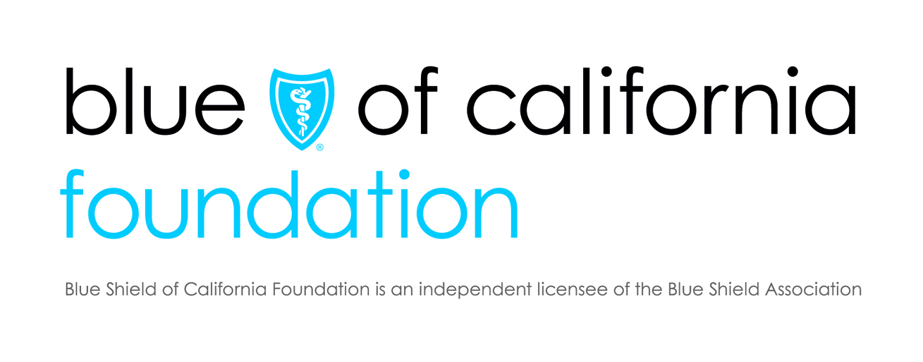

Building Movement for the Work Ahead
Blue Shield of California Foundation Advancing Behavioral Health Integration
Grantee Convening
July 14 – 15, 2016

Convening Objectives:
- Build community among Advancing Behavioral Health Integration initiative partners
- Explore behavioral health integration through the lens of social determinants of health
- Share strategies, resources, and promising practices

Thursday, July 14, 2016
6:00 – 7:30 p.m. Hosted Reception

Friday, July 15, 2016
8:00 – 8:30 a.m. Check-in/Breakfast

8:30 – 9:30 a.m. Welcome and Opening Remarks
Rachel Wick, Senior Program Officer, Health Care and Coverage
Blue Shield of California Foundation

9:00 – 9:30 a.m. Telling the Stories of Behavioral Health Integration

9:30 – 10:45 p.m. Framing Behavioral Health through the Lens of Health Equity and Social Determinants of Health
Larry Cohen, Executive Director
Prevention Institute

10:45 – 11:00 a.m. Break/Instant Recess

11:00 – 12:30 p.m. Peer Learning Roundtables
Facilitated discussions on priority issues

12:30 – 1:45 p.m. Lunch

1:45 – 3:00 p.m. Telling the Stories of Behavioral Health Integration
Moderator: Ingrid Madden, Communications Associate
Blue Shield of California Foundation
- Andrea Castillo, The Fresno Bee
- Leila Day, KALW

3:00 – 3:20 p.m. Advancing BHI 201: What are the practices and working assumptions?

3:20 – 3:30 p.m. Closing

3:30 p.m. Adjourn

